# **Laboratory-2**

## **QUESTION-1**

## Write a Lex and Yacc code for syntax analysis of arithmetic, boolean and relational operators in C.

### **Lex File (lex.l):**

%{

#include <stdio.h>

#include <stdlib.h>

#include "y.tab.h"

**extern** yylval;

%}

%%

[a-zA-Z][a-zA-Z0-9]* {**return** id;}

[0-9]+ {yylval=atoi(yytext);**return** num;}

[\t] {;}

[\n] {**return** 0;}

. {**return** yytext[0];}

%%

### **Yacc File (yacc.y):**

%{

#include <stdio.h>

#include <stdlib.h>

**int** res;

%}

%token id num

%%

stmt:expr{res=$$;};

expr:expr '+' expr {$$=$1+$3;}

|expr '-' expr {$$=$1-$3;}

|expr '*' expr {$$=$1*$3;}

|expr '/' expr {$$=$1/$3;}

|expr '<' expr {$$=($1<$3);}

|expr '>' expr {$$=($1>$3);}

|expr '<' '=' expr {$$=($1<=$4);}

|expr '>' '=' expr {$$=($1>=$4);}

|expr '=' '=' expr {$$=($1==$4);}

|'(' expr ')'{$$=$2;}

|id

|num

;

%%

**int** main()

{

printf("Enter an expression : ");

yyparse();

printf("\nThe result is : %d",res);

**return** 0;

}

**int** yyerror()

{

printf("Error!");

exit(0);

}

### Input/Output:

## **Result**:

Lex and Yacc code to perform syntax analysis of boolean, relational and algebraic operators has been implemented successfully.

## **QUESTION-2**

## Write a program to construct a symbol table in C.

### Code:

#include <stdio.h>

#include <stdlib.h>

#include <string.h>

**typedef** **struct** {

**char** name[50];

**char** datatype[20];

**int** offset;

**int** size;

**char** scope[20];

} SymbolEntry;

**typedef** **struct** {

SymbolEntry entries[100];

**int** count;

} SymbolTable;

**void** initSymbolTable(SymbolTable *table) {

table->count = 0;

}

**void** addEntry(SymbolTable *table, **const** **char** *name, **const** **char** *datatype, **int** offset, **int** size, **const** **char** *scope) {

**if** (table->count < 100) {

SymbolEntry *entry = &(table->entries[table->count]);

strcpy(entry->name, name);

strcpy(entry->datatype, datatype);

entry->offset = offset;

entry->size = size;

strcpy(entry->scope, scope);

table->count++;

} **else** {

printf("Symbol table full, cannot add entry.\n");

}

}

**void** displaySymbolTable(**const** SymbolTable *table) {

printf("Name\tDataType\tOffset\tSize\tScope\n");

printf("---------------------------------------------\n");

**for** (**int** i = 0; i < table->count; i++) {

SymbolEntry entry = table->entries[i];

printf("%s\t%s\t\t%d\t%d\t%s\n", entry.name, entry.datatype, entry.offset, entry.size, entry.scope);

}

}

**int** main() {

SymbolTable symbolTable;

initSymbolTable(&symbolTable);

addEntry(&symbolTable, "x", "long", 4, **sizeof**(**long**), "global");

addEntry(&symbolTable, "y", "long long", 8, **sizeof**(**long** **long**), "local");

displaySymbolTable(&symbolTable);

**return** 0;

}

## **Output:**

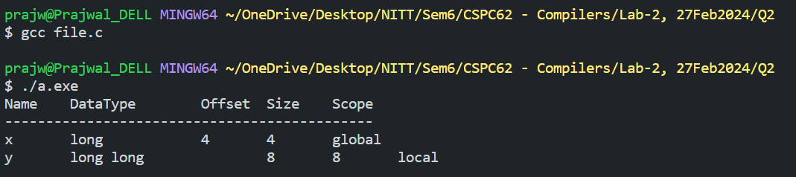

## **Result:**

C program to illustrate the working of aa symbol table has been implemented successfully.